Information Systems Project - 2018

<Project Number: Name>

# User Manual

Version X.X

MM/DD/YYYY

Document Number: <document’s configuration item control number>

Contract Number: <current contract number of company maintaining document>

Table of Contents

1. Introduction 1

2. Overview 2

2.1 Conventions 2

2.2 Cautions & Warnings 2

3. Getting Started 3

3.1 Set-up Considerations 3

3.2 User Access Considerations 3

3.3 Accessing the System 3

3.4 System Organization & Navigation 3

3.5 Exiting the System 3

4. Using the System 4

4.1 <Given Function/Feature> 4

4.1.1 <Given Sub-Function/Sub-Feature> 4

5. Troubleshooting & Support 5

5.1 Error Messages 5

5.2 Special Considerations 5

5.3 Support 5

Appendix A: Record of Changes 6

Appendix B: Acronyms 7

Appendix C: Glossary 8

Appendix D: Referenced Documents 9

Appendix E: Approvals 10

Appendix F: Additional Appendices 11

Appendix G: Notes to the Author/Template Instructions 12

Appendix H: XLC Template Revision History 13

List of Figures

**No table of figures entries found.**

List of Tables

Table 1 - Support Points of Contact 5

Table 2 - Record of Changes 6

Table 3 - Acronyms 7

Table 4 - Glossary 8

Table 5 - Referenced Documents 9

Table 6 - Approvals 10

Table 7 - XLC Template Revision History 13

## Introduction

This project is proposing for a MILCO SALES OUTLET company which situated in RAGAMA. According to the company process they buying a different type of milco products from milco suppliers and selling them to outside buyers.

As the client’s requirement, they have two types of suppliers and they need a good database to handle their supplier’s details. And they need a good stock maintenance system too.as well as the company has a large number of working employees. So it has begun a huge problem in handling their day process. So that we proposing a project to implement a system which helps to solve those problems and a systems that easily can handle in company day to day work process.

Our client name is Mrs. N.A.P Nirmala De Silva. She is the Agent of this Milco Outlet which situated in Ragama. She is a good experienced Business women and she hoping to spread her Milco outlets in Kadawathe, Colombo areas also.

## Overview

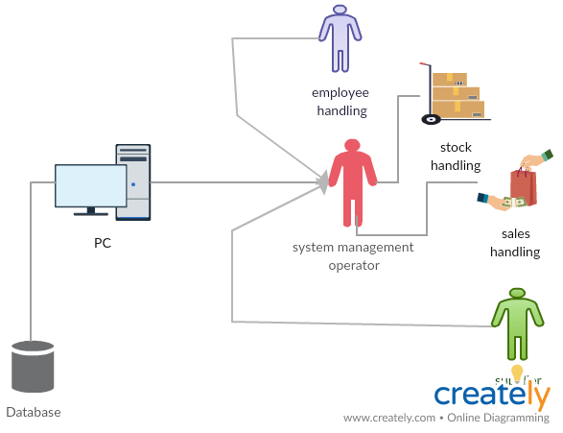

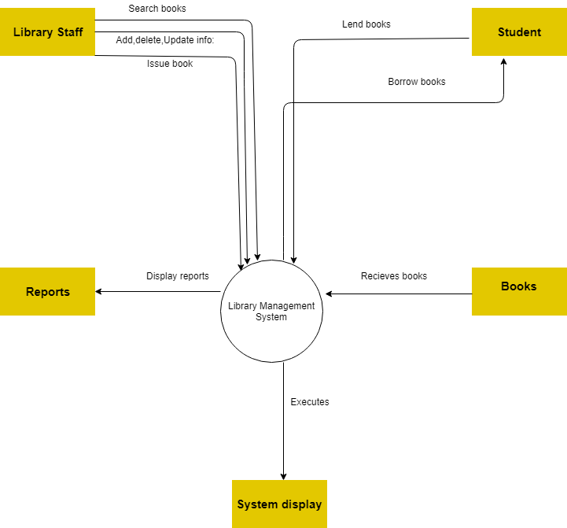The main functions of this system are as follows.

* Employee handling
* Stock handling
* Sales handling
* Supplier handling

Before doing the following functions authorized persons should login to the system by proving valid username and the password.

In employee handling section system staff members can insert, update, delete, search, view and generate report about the employees. In stock handling section staff members can insert, Update delete and generate reports about the stock available in the system. In sales handling section describe about day to day sales. In supplier section provide details about suppliers.

**User Interface of the member details**

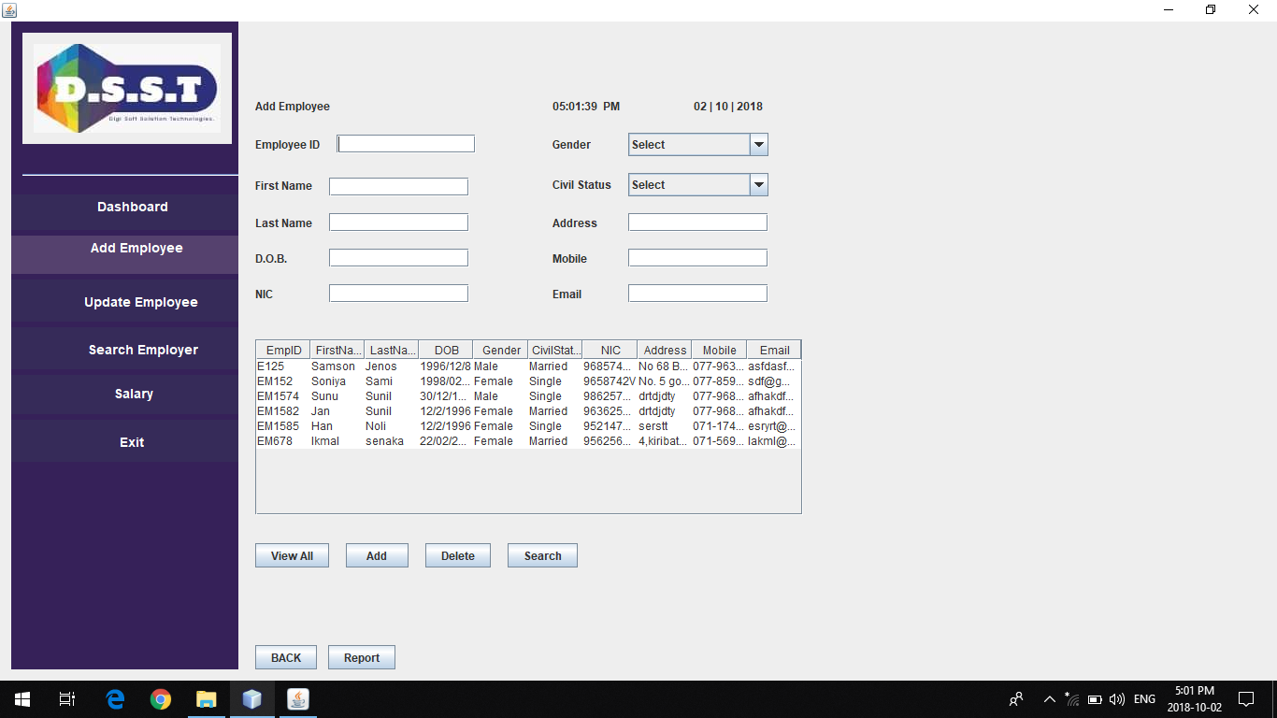

**User Interface of Add stock**

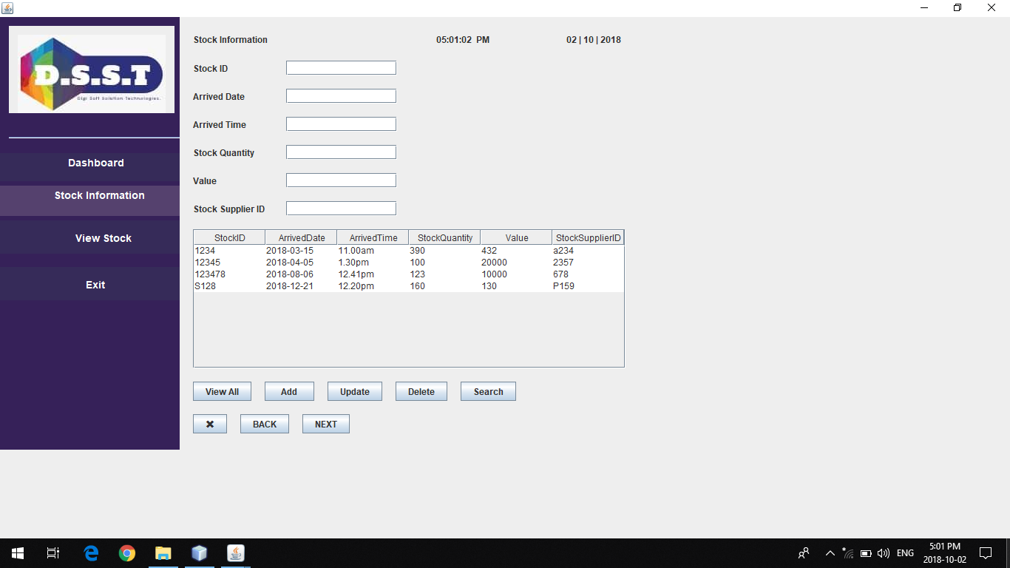

**User Interface of Update, Delete and Search Item**



**User Interface of sales**

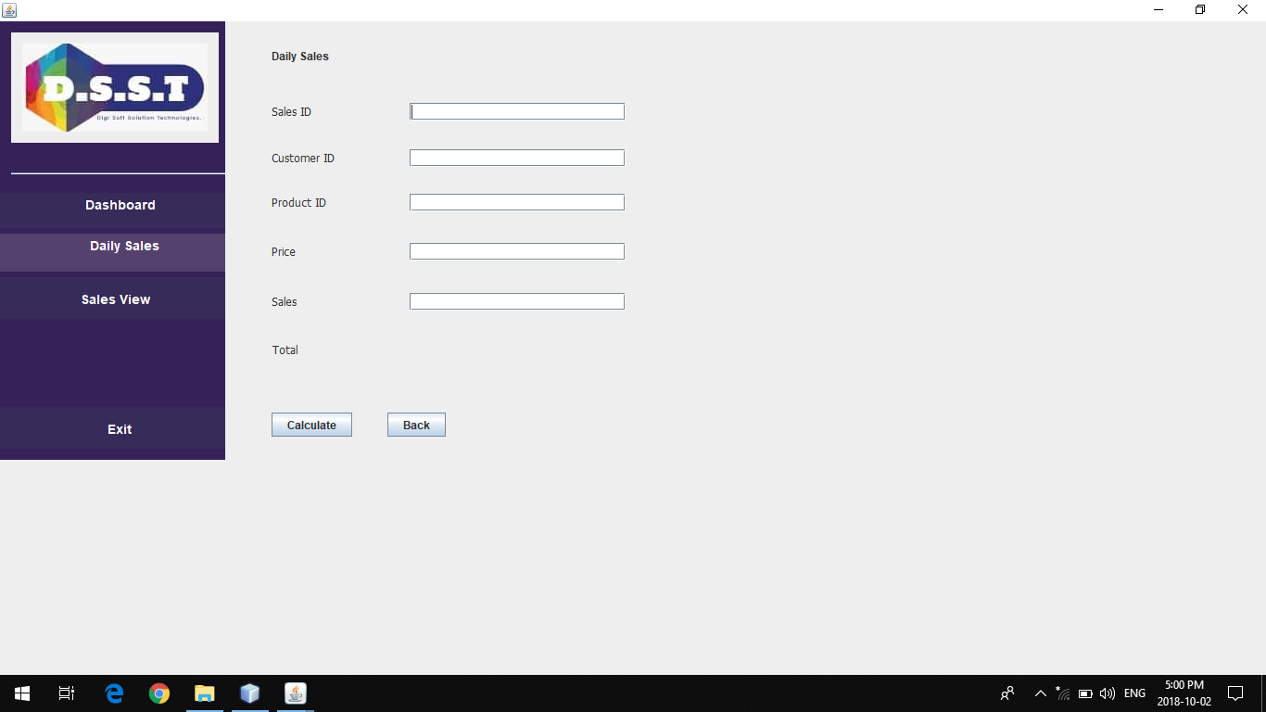

**User Interface of Customer**

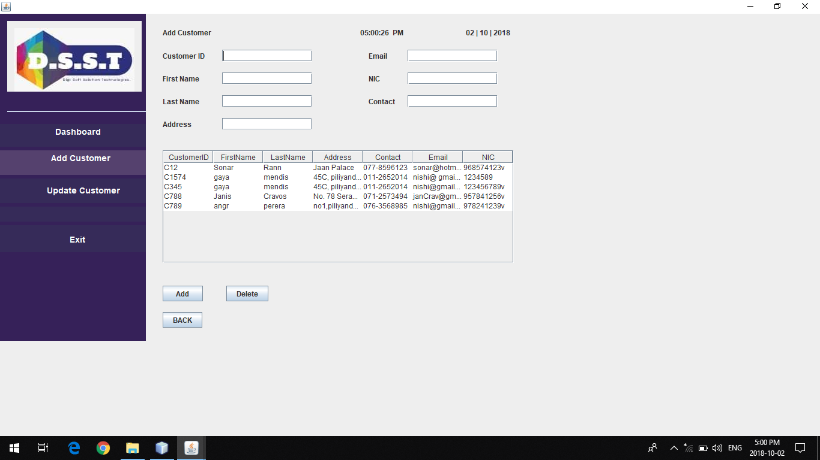

**User Interface of Supplier**

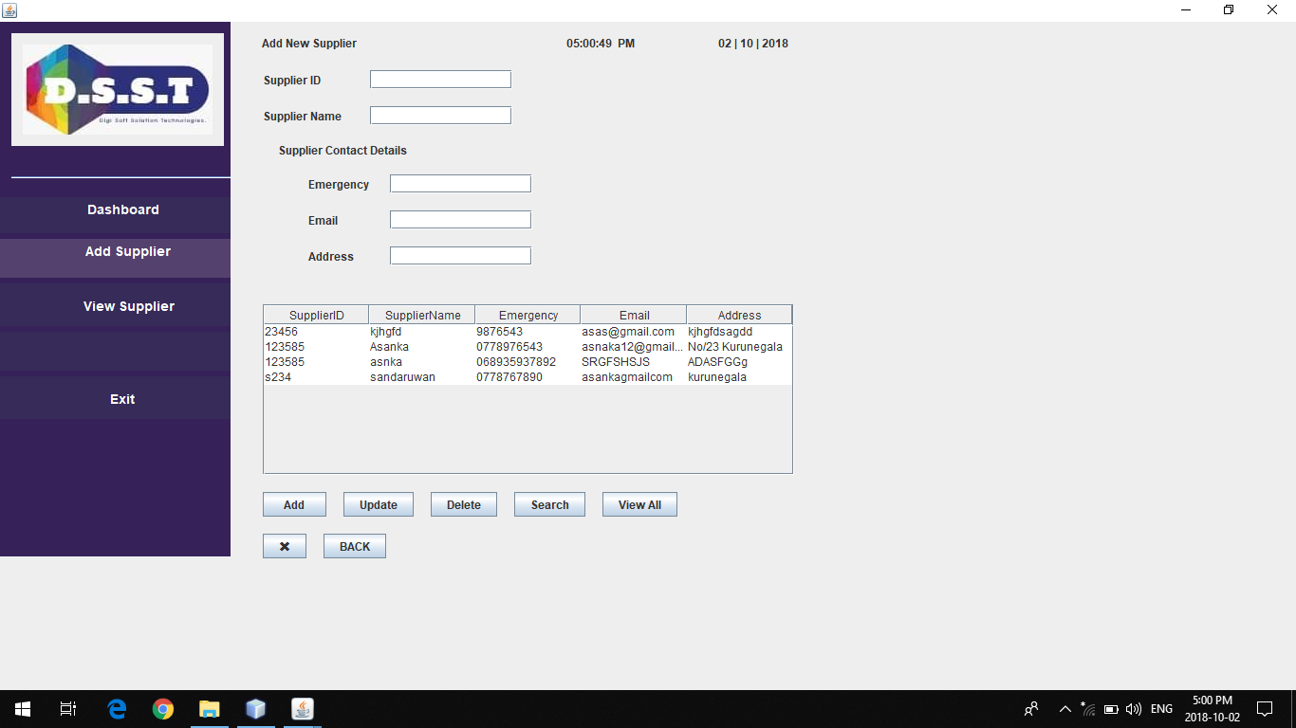

When user log into the Milco Outlet Handling system he or she should provide valid username and the password to the login part. After getting access to the system user can perform tasks available in the system. When inserting new details in to the Employee, stock, sales, supplier to databases users can use add, delete, update, and search functions. After inserting, updating, deleting a member from the member details interface message is popup as “Insert Successful” moreover in member details interface table load is there therefore everyone able to see the prevailing information in member database by using table load in the member details interface. Furthermore when inserting information

if there were empty fields available pop up a message by telling “ ”. In each interface, when adding details in to the databases user must be fil all fileds, otherwise error message will be display.

This system is developed in a user friendly environment with user friendly interfaces.

### Conventions

This document provides screen prints and corresponding narrative to describe how to use the <System Name and/or Acronym>.

When an action is required on the part of the reader, it is indicated by a line beginning with the word “Action:” For example:

Action: Click on OK.

Fields or buttons to be acted upon are indicated in bold italics in the Action statement; links to be acted upon are indicated as links in underlined blue text in the Action statement.

Note: The term ‘user’ is used throughout this document to refer to a person who requires and/or has acquired access to the <System Name and/or Acronym>.

### Cautions & Warnings

There is no any unauthorized access to the system.

## Getting Started

When user need to getting start the system, user have to give correct user name and the password. Otherwise user cant login to the system.

**Interface of Login**

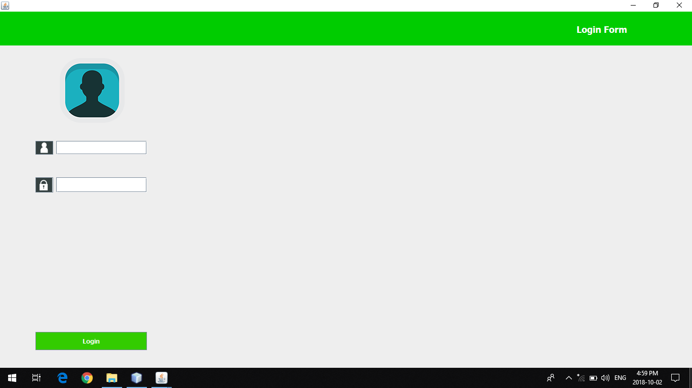

After logging to system successfully, system will load the main frame for all functions which call as “Dash Board”.

**Functions login**

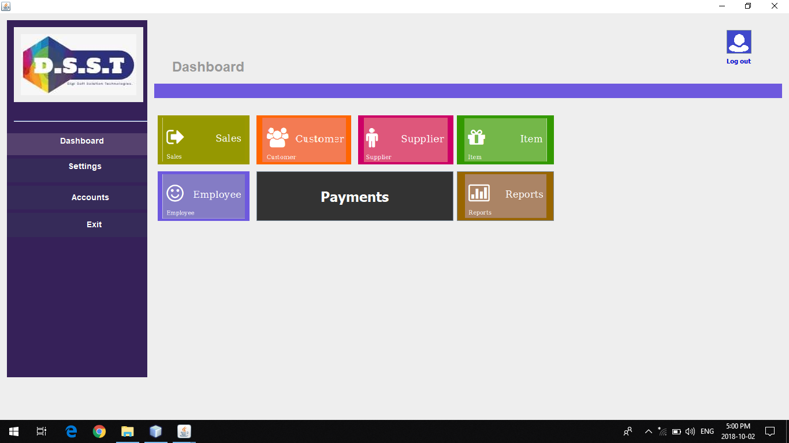

**Sales interface.**

If the user wants to do access sales function, user have to click on sales button. Then the system will load the sales first interface. Then user can do his task according to sales.



From this interface user can calculate daily sales. And user can weave daily sales from clicking

View sales button.

**Customer interface**

If the user want to access customer function, user have to click customer button. Then the system will load the customer interface and user can do his task according to customer interface. 

**Supplier Interface**



If the user needs to access supplier details and other tasks, user have to click supplier button and do his task on it.

**Item interface**

If the user wants to do tasks in item interface he needs to click item button. Then the system will load the item interface and user can add products from that interface.

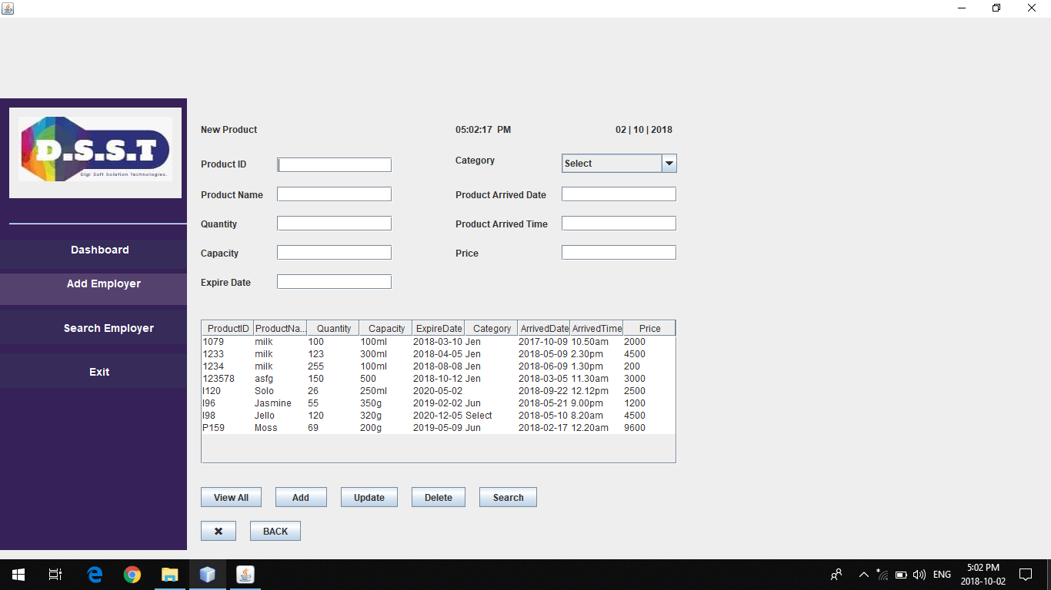

**Employee Interface**



If the user needs to add new employees to the system, first user have to click employee button. Then the system will load the employee registration interface. After that user can do his task on employee interface.

**Payments interface**



If the user needs to payment the employees to the system, first user have to click payment button. Then the system will load the payment interface. After that user can do his task on payment interface and calculating employee salary.

### Set-up Considerations

To access this outlet system user didn’t need network access. Therefore the user can easily handle the tasks without any trouble. DELL core i3 or higher version can support this system and computer monitor and printers are need as output devices. Recommended screen resolution is 1366*768.

CMS screens are designed to be viewed at a minimum screen resolution of 800 x 600. To optimize your access to the <System Name and/or Acronym>:

1. Please disable pop-up blockers prior to attempting access to the <System Name and/or Acronym>.
2. Use Internet Explorer, version 6.0 or higher.

### User Access Considerations

Only the 2users have responsibility to access the system. This system is installed only in the computer located in the outlet.

### Accessing the System

If the user provides correct username and password only he/she can access the system.

### 

### System Organization & Navigation

The home page of this system looks like this

**

After the successful login navigation path to the main function interface is display in the screen. Then the user can click on particular function button and can perform tasks they want to do.

* Employee handling
* Stock handling
* Sales handling
* Supplier handling

### Exiting the System

## Using the System

The following sub-sections provide detailed, step-by-step instructions on how to use the various functions or features of the <System Name and/or Acronym>.

### <Given Function/Feature>

#### <Given Sub-Function/Sub-Feature>

## Troubleshooting & Support

### Error Messages

In member details when entering a name, user have permission to enter strings only if the user types a number system popup a message “please input string?” When inserting details to the database when one field is empty system popup a message by telling “complete all the fields” When insert customer to the customer number of copies available in the system also entered to the database.

### Support

| Contact | Organization | Phone | Email | Role | Responsibility |
| --- | --- | --- | --- | --- | --- |
| Nirmalada Silva | milco outlet system | 0776427126 | rashmisarala3@gmail.com | owner | owner |

Appendix A: Record of Changes

Instructions: Provide information on how the development and distribution of the User Manual will be controlled and tracked. Use the table below to provide the version number, the date of the version, the author/owner of the version, and a brief description of the reason for creating the revised version.

Table 2 - Record of Changes

| Version Number | Date | Author/Owner | Description of Change |
| --- | --- | --- | --- |
| <1.0> | <02/09/2018> | CMS | < Change the funtion> |
|  |  |  |  |
|  |  |  |  |

Appendix B: Acronyms

Instructions: Provide a list of acronyms and associated literal translations used within the document. List the acronyms in alphabetical order using a tabular format as depicted below.

Table 3 - Acronyms

| Acronym | Literal Translation |
| --- | --- |
| <Acronym> | <Literal Translation> |
| <Acronym> | <Literal Translation> |
| <Acronym> | <Literal Translation> |

Appendix C: Glossary

Instructions: Provide clear and concise definitions for terms used in this document that may be unfamiliar to readers of the document. Terms are to be listed in alphabetical order.

Table 4 - Glossary

| Term | Acronym | Definition |
| --- | --- | --- |
| <Term> | <Acronym> | <Definition> |
| <Term> | <Acronym> | <Definition> |
| <Term> | <Acronym> | <Definition> |

Appendix D: Referenced Documents

Instructions: Summarize the relationship of this document to other relevant documents. Provide identifying information for all documents used to arrive at and/or referenced within this document (e.g., related and/or companion documents, prerequisite documents, relevant technical documentation, etc.).

Table 5 - Referenced Documents

| Document Name | Document Location and/or URL | Issuance Date |
| --- | --- | --- |
| <Document Name> | <Document Location and/or URL> | <MM/DD/YYYY> |
| <Document Name> | <Document Location and/or URL> | <MM/DD/YYYY> |
| <Document Name> | <Document Location and/or URL> | <MM/DD/YYYY> |

Appendix E: Approvals

The undersigned acknowledge that they have reviewed the User Manual and agree with the information presented within this document. Changes to this User Manual will be coordinated with, and approved by, the undersigned, or their designated representatives.

Instructions: List the individuals whose signatures are desired. Examples of such individuals are Business Owner, Project Manager (if identified), and any appropriate stakeholders. Add additional lines for signature as necessary.

Table 6 - Approvals

| Document Approved By | Date Approved |
| --- | --- |
| Name: <Name>, <Job Title> - <Company> | Date |
| Name: <Name>, <Job Title> - <Company> | Date |
| Name: <Name>, <Job Title> - <Company> | Date |
| Name: <Name>, <Job Title> - <Company> | Date |

Appendix F: Additional Appendices

Instructions: Utilize additional appendices to facilitate ease of use and maintenance of the document.

Appendix G: Notes to the Author/Template Instructions

This document is a template for creating a User Manual for a given investment or project. The final document should be delivered in an electronically searchable format. The User Manual should stand on its own with all elements explained and acronyms spelled out for reader/reviewers, including reviewers outside CMS who may not be familiar with CMS projects and investments.

This template includes instructions, boilerplate text, and fields. The developer should note that:

* Each section provides instructions or describes the intent, assumptions, and context for content included in that section. Instructional text appears in blue italicized font throughout this template.
* Instructional text in each section should be replaced with information specific to the particular investment.
* Some text and tables are provided as boilerplate examples of wording and formats that may be used or modified as appropriate.

When using this template, follow these steps:

1. Table captions and descriptions are to be placed left-aligned, above the table.
2. Modify any boilerplate text, as appropriate, to your specific investment.
3. Do not delete any headings. If the heading is not applicable to the investment, enter “Not Applicable” under the heading.
4. All documents must be compliant with Section 508 requirements.
5. Figure captions and descriptions are to be placed left-aligned, below the figure. All figures must have an associated tag providing appropriate alternative text for Section 508 compliance.
6. Delete this “Notes to the Author/Template Instructions” page and all instructions to the author before finalizing the initial draft of the document.

Appendix H: XLC Template Revision History

The following table records information regarding changes made to the XLC template over time. This table is for use by the XLC Steering Committee only. To provide information about the controlling and tracking of this artifact, please refer to the Record of Changes section of this document.

This XLC Template Revision History pertains only to this template. Delete this XLC Template Revision History heading and table when creating a new document based on this template.

Table 7 - XLC Template Revision History

| Version Number | Date | Author/Owner | Description of Change |
| --- | --- | --- | --- |
| 1.0 | 04/16/2008 | ESD Deliverables Workgroup | Baseline version |
| 2.0 | 08/18/2014 | Celia Shaunessy, XLC Steering Committee | Changes made per CR 14-012 |
| 2.1 | 02/02/2015 | Surya Potu, CMS/OEI/DPPIG | Updated CMS logo |
| 3.0 | 06/02/2017 | CMS | * Updated template style sheet for Section 508 compliance * Added instructional text to all blank cells in tables * Added Acronym column to Table 4 - Glossary * Reformatted Table 6 - Approvals in Appendix E: Approvals for Section 508 compliance * Changed location of Appendix F: Additional Appendices so that it resides below Appendix E: Approvals and is no longer the last appendix in the template * Added instructional text to Appendix H: XLC Template Revision History instructing authors to delete this appendix when creating a new document based on this template |